
SCHOOL OF COMPUTER APPLICATION

Department of MCA
ACADEMIC YEAR: - 2024-25
Project Synopsis Format Prepared by: - Abhi Gupta

Title of the Project
Flight Operation Hub

Introduction:
- The Flight Operation Hub aims to provide a real-time and automated solution for airline operations, including ticket booking, flight scheduling, passenger management, and cancellations. This system will help airlines streamline their operations, reduce manual workload, and enhance customer experience by providing a simple, efficient, and secure way to manage airline services.
- With the increasing number of air travellers, airlines require a robust and scalable system that can handle bookings, cancellations, and flight status management effectively. This project will ensure that passengers and administrators have a seamless experience in managing airline operations.

Objectives of the Project:
- To develop a fully automated Flight Operation Hub that simplifies booking, cancellations, and passenger management.
- To integrate real-time flight scheduling and status updates for passengers and administrators.
- To provide a secure user authentication system for passengers and airline staff.
- To ensure seamless payment processing through multiple online payment gateways.
- To generate reports for airline operators, including financial summaries, flight occupancy, and operational insights.
- To create a user-friendly graphical interface for both passengers and administrators.

Scope of the Project

- User Registration and Authentication: Secure login system for passengers and airline staff.
- Flight Management: Admins can schedule, update, and cancel flights.
- Ticket Booking System: Passengers can search for flights, check availability, and book tickets.
- Payment Integration: Secure payment processing via credit/debit cards, UPI, and online banking.
- Boarding Pass Generation: Automated boarding pass generation for passengers.
- Cancellation and Refund System: Manage ticket cancellations and process refunds.
- Admin Dashboard: Airline staff can monitor bookings, manage flights, and generate reports.
- Notification System: Sends email/SMS alerts for flight updates, cancellations, and booking confirmations.
- Reports and Analytics: Generates detailed reports on flight occupancy and revenue.

Methodology

- Requirement Gathering: Understanding airline operations and user needs.
- System Design: Creating wireframes, ER diagrams, and flowcharts.
- Development:
  - Frontend Development: Using Java Swing for desktop or ReactJS for web UI.
  - Backend Development: Implementing business logic in Java.
  - Database Integration: Using MySQL for storing passenger details, flight data, and transactions.
- Testing: Conducting unit testing, integration testing, and user acceptance testing.
- Deployment: Installing the system in a real-world airline environment.
- Maintenance and Updates: Continuous improvements based on user feedback.

- System Architecture / Block Diagram:

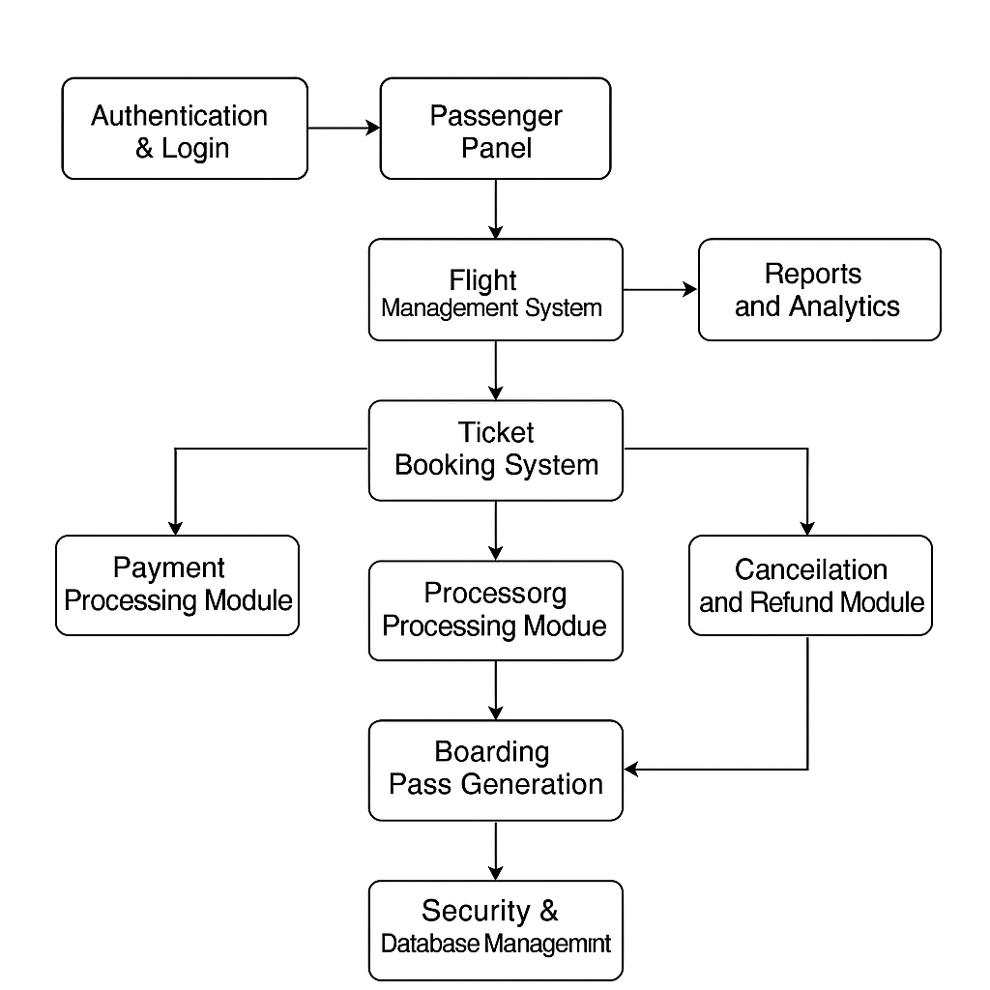

- Modules

- Cancellation and Refund Module
  - Passengers can cancel bookings with refund processing.
  - Automated notifications for cancellation confirmation.
- Notification System
  - Email and SMS alerts for flight bookings, delays, and cancellations.
  - Reminder notifications before departure.
- Reports and Analytics Module
  - Generates reports for airline operators on bookings, revenue, and occupancy.
  - Provides insights into peak travel periods and trends.
- Data Security Module
  - Encryption for sensitive user data.
  - Secure authentication and session management.
- Admin Dashboard Module
  - A web-based or desktop admin panel to manage airline operations.
  - Graphical data representation for easy decision-making.

- Feasibility Study
- Technical Feasibility:
  - Uses Java, MySQL, and APIs for online payments and real-time flight tracking.
  - Secure authentication and data encryption to ensure passenger safety.
- Economic Feasibility:
  - Development costs are minimal with open-source tools.
  - Future revenue potential through premium services and airline partnerships.
- Operational Feasibility:
  - Easy to implement within existing airline systems.
  - Works in both online and offline modes for reliability.

Expected Outcomes

- A fully functional Flight Operation Hub that simplifies airline operations.
- Efficient ticket booking, cancellation, and refund management.
- Real-time flight status updates and seat availability tracking.
- Secure payment processing with automated invoicing.
- Automated report generation for improved airline decision-making.
- User-friendly interface for both passengers and airline staff.

Project Plan and Timeline
Phase | Activities | Start Date
Project Title Submission | Submission of project title | 10/01/2025
Project Synopsis Submission | Provide project details to guide | 16/01/2025
Designing | Draw ERD, UML, and module hierarchy diagrams | 30/01/2025
User Interface | Prepare UI and get approval | 20/02/2025
Database Design | Design database structure and data dictionary | 06/03/2025
Coding | Develop the project with validation and error handling | 20/03/2025
Report Submission | Submit final project report | 03/04/2025
Internal Project Viva | Conduct project presentation and viva | 10/04/2025

- Conclusion
The Flight Operation Hub will provide a fully automated solution for airlines to manage their operations efficiently. With features like ticket booking, cancellations, real-time flight updates, and secure payments, the system will significantly reduce manual work and improve customer satisfaction. This project also serves as a learning tool for developers working with Java, databases, and GUI applications. Future enhancements could include AI-based pricing optimization, cloud integration, and mobile app support. The project aims to revolutionize airline management by leveraging technology for better efficiency and security.

Signature of the Student | Date of Synopsis Submission
Signature of the Faculty | Date of Approval

